Name: yendluri pavan Ram Chandar

Roll No: RK0260A01

Section: KO260

Subject: GEN330

CA No:2

***IOT-based smart garbage system for food waste management***

**Pavan Yendluri1\***

**1**Depeartment of computer science, Lovely Professional University, Phagwara-144411, India.

*[pavanyendluri588@gmail.com](mailto:pavanyendluri588@gmail.com)

***Abstract***

**Due to the significant change in the Internet of Things (IoT), I have been researching IoT services in many fields. One such issue has become waste management as a major IoT application area. Absence of efficient waste management. It has caused serious environmental and cost problems. Therefore, the IoT-based Smart Garbage System (SGS) in this paper. It suggests reducing the amount of food waste. In the SGS system, Smart Battery Bins (SGBs) exchange information. They use wireless mesh networks with each other, and the router and server collect and analyze information to provide services. In addition, SGS incorporates various IoT techniques for user convenience and extends battery life in two types of energy efficient SGB operations: stand-alone operation and cooperative operation. Designed by SGS was operated as a pilot project in the Gangnam district of Seoul, the Republic of Korea for one year. The experiment showed that we could reduce the average amount of food waste by 33%.**

***Keywords: Arduino; Raspberry pi; Robotics; Garbage; IOT; GPS.***

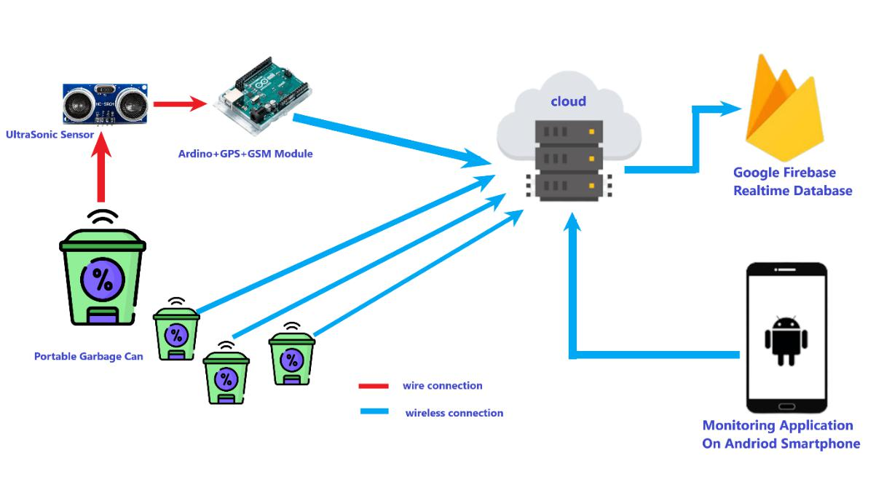

Figure 1: IoT-based Smart Garbage Architecture

***Highlights:***

* **We mainly use the Smart garbage system for metro political cities because it is very difficult to manage garbage systems in such huge, populated cities.**
* **The smart bin or portable garbage can will collect the data like the amount of trash and type of garbage by using the**

**ultrasonic sensor.**

* **The data collected by the ultrasonic sensor are sent to the cloud using the Arduino board and internet.**
* **The data stored on the firebase is used to predict the feature garbage data according to areas.**
* **The data stored on the firebase is accused by the android phone and used to see the live data using the android phone.**

***References***

Kanade, P., Alva, P., Prasad, J. P., & Kanade, S. (2021, April). Smart garbage monitoring system using Internet of Things (IoT). In 2021 5th International Conference on Computing Methodologies and Communication (ICCMC) pp. 330-335.